SECURING THE

AUTO INDUSTRY

*How to reimplement organization and validate e-sign during business transactions and deals.*

10/6/2018

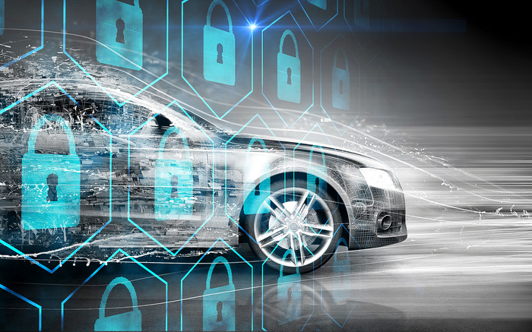

Shaheda K. Choudhury

Georgia state univesity

Final Exam- cis 8080

Table of Contents:

Part I. Executive Summary 2

***Recommendation*** 2

***Background*** 2

***Analysis*** 3

***Course of Action*** 3

***Criteria*** 3

***Restated Recommendation*** 3

Part II. Executive Paper 4

***Introduction*** 4

***Problems*** 6

***Internal Infrastructure*** 7

***Analysis*** 8

***Solutions*** 10

***Conclusion*** 11

Part III. Sources 13

# **Part I. Executive Summary**

## ***Recommendation***

My recommendation is for the auto industry to reconsider the use of DocuSign, e-signatures and electronic records during business transactions.

## ***Background***

I recently bought a car for the first time. I was excited, and naively thought I was going to take only a few hours of my day. At the dealership, I filled out paper work for one car which unfortunately did not approve for finances with the bank. Then after picking another car, I got approved and had to refill new paper work for the car. Then during the process of financing, it with the bank, the dealership handed me a huge stack of papers which was the final contract that I needed to sign. A SINGLE letter of my name was misspelled which lead the associate to reprint a stack of paperwork and me resigning all the documents again. The associate showed me under a huge legal pad, an unused DocuSign machine which was collecting dust because the courts for the industry claim that e-signatures are not secure and do not hold value.

This issue is very problematic because, it wasted a lot of time on everyone’s behalf. I had to sign all the paper work, the associate needed to reprint and reverify everything as well. Secondly, this wastes lots of resources such as paper and ink. Finally, by not having electronic records, this led to a lack of organization. The first temporary tag that the associates provided me was for a completely wrong car, and I needed to request for the right one. Again, wasting all those resources just for some mistakes that are avoidable if digital record keeping was allowed in the industry. These simple mistakes are what causes buying a car take an unreasonable 6-8 hours rather than anything less than that.

## ***Analysis***

|  |  |
| --- | --- |
| ***Course of Action*** | ***Criteria*** |
| * Implement an organized and rewriteable e-file system for paper work. | * Makes the process of buying a car easier. |
| * Creating ways to secure, and cancel signatures when contracts fall out. | * Validates signatures when needed and void them when not needed. |
| * Identify ways to reduce the waste of resources and time. | * Save money and the environment by being more resourceful. |

*Table comparing the course of action against the criteria.*

The first course of action is the implementation of an electronic organization system, this will allow a dramatic reduction in time it takes for a customer to buy a car and result in a more efficient system for both the buys and the dealership. The second action that needs to take place is to create a system for verification if a contract and the signature is still being upheld and honored. For this, a verification needs to be sent to the buy and another to the dealer that shows clearly that the contract is still being signed and executed as agreed. If one side of the contract signature disagrees about the agreement, then the contract and signature automatically become nullified. The final course of action is to find ways to reduce waste which allows saving money on resources and the environment from unassay papers to be printed. By making this change a dealership can reduce operational costs such as paper, ink and pens.

## ***Restated Recommendation***

It is essential that the auto industry changes its views on organization, e-documentations and resource managements. With these changes, customers, employees and dealership will benefit in being more productive in their operations.

# **Part II. Executive Paper**

## ***Introduction***

Having a car is one of the most important machines that someone can own. Like any machine, a car needs to be kept in tune and constantly given its power source. While cars traditionally use gasoline, natural gas or diesel today with the changing of technologies we have moved into new sources of power such as electric and solar. Which are changing a cars structure from being a machine of the typical nuts and bolts to one such as a computer. With these changes we have had mad advances in car securities too. When Bluetooth was developed into cars, auto company’s technology teams needed to figure out how to secure the connections and develop ways to ensure that one person’s calls are not intercepted by another car nearby.

Everywhere we look we see how technology is advancing and how records, events and businesses are moving towards a more digital world. Many of us work and interact with people who need out signatures. Often, we will not have the ability to meet with them and sign the paperwork and give it to that, so technology has come up with a resolution to this problem well known as DocuSign. This advance has not only allowed people to connect from remote, but also allow a way to implement an electronic recoding system. According to the DocuSign web site, over 300,000 business worldwide use their services. (2017)

When purchasing a car, we all know the process is a time consuming one when you are open to options. The process can take anywhere between 2 to 7 hours for a machine that you may keep anywhere between 2 to 11 years. It may take longer when simple mistakes are made too, for example misspelling of personal information. This not only causes aggression for the consumers but also dealership employees. Someone may have signed many papers, but then notice a name or number is wrong. This requires the whole set of papers to be reprinted and resigned sometimes twice or more if multiple car applications were submitted. Additionally, the resources used up for all these are not only an inefficient but may also lead to losses at the end of the year.

These problems occur because the auto industry, refuses to acknowledge DocuSign and electronic filing systems even though most dealership managers are already equipped with the equipment. The auto industry does not use electronic records and DocuSign systems, are because US courts for the auto industry do not believe that these signatures are secure. These courts claim that they cannot securely said that the electronic signatures do indeed come from the person who signs. In simpler terms, this leads to many cases of fraud, therefor reduce the court cases which results from these issues the consensus is for the signatures to become non-validated in the system. This essentially lead the dealerships no choice but to revert to using paper recording systems and signatures.

In this paper, I will explain more about my recommendation, which is to the auto industry to reconsider the use of DocuSign, electronic signatures and electronic records during business transactions. Furthermore, I will discuss some basic background to fully comprehend the issues, and how we can improve securities for problem such as electronic signature verification and create solutions that I hope will convince the auto industry to change many of its wasteful practices. This paper is intended to both inform and persuade the management team of any auto dealership, that alternatives are available for problematic practices in the industry.

## ***Problems***

Before going into solutions of the problem, we need to fully comprehend what the problem is. For this we need to look at the history of frauds in the auto industry. There are reports from as early as 1920 where a sales associate had sold a use car as new. (Gardemal, 2017) At any given moment in time, if we search anything about the auto industry it granted that we will be able to find some sort of activity going around. This can involve anything from new technologies, trade deals, hijackings or even frauds and scams.

Cars are an important part of American life and society; many people only have cars their main way of commuting around the city. According to data from the US Census Bureau, in 2017 there was 269 million US vehicle registrations and 6.3 million cars sold. While the population of adults over 18 in the US is about 75 million. This means that the ownership of cars is 75% more than the adult population of the US. Furthermore, only 222 million of the registered car owners are also licensed drivers. This leaves about 70 million people who have registered cars but no licenses too, which proves that having a registered car under your name serves more of the purpose than just driving it around. (Laporte)

In more recent news, due to electronic signatures dealerships have been running new types of high-tech scams. These scams often target people who are trying to apply for financing for an auto loan. In an article written by Ryan Felton in 2017, he talks about examples of real-life people who used the DocuSign system and got denied the application but anyways ended up with the debt of the loan. (Felton, 2017) This then caused an influx of lawsuits where they needed to resolve this problem. Furthermore, another case showed how a sales man was able to sign a customer’s name and agree to a contract with rates way out of the scope that they had initially agreed to.

## ***Internal Infrastructure***

DocuSign is a company which was evaluated at $4.41 billion when they are opening shares (DOCU) in early 2017. (Klingel, 2018) Which means, these signatures are making people rich and worth some big bucks, subsequently, because of this the legal portion of the site is very interesting to examine. According to the DocuSign legal site, all signatures that are signed used by the software are legally binding all over the world. Taking a deeper look into the laws from the US, we see that the government has created the ESIGN Act and the Uniform Electronic Transaction Act. (Kingel, 2018)

These acts ensure that, verification of signer identities with multiple forms for authentication and links signatures to the signers and the documents. Confirmation of the signer intent to sign electronically. Allow ongoing secure access to DocuSign documents. Protect documents with tamper-seals that use a combination of Public Key Infrastructure and secure system processes. Record all important documents and signature activities and automatically generated and stored time stamped history of ever send, view, print, sign or decline actions on the document. ISO 270001- Information Security Management Systems standards that keep information assets secure, compliant.

With all these regulations we can clearly understand how an e-signature is valid and legally binding. However, an important thing that all these regulations is lacking is the rules on what happens when a contract falls though. This is often a problem that happens in the auto industry where you may look to buy a certain car, but something causes you to not be eligible to buy that certain car.

## ***Analysis***

Before, diving right into ways we should fix these problems, first we need to understand a little bit about the infrastructure that was discussed above. The interesting parts that will be discussed are: time stamping, encryption and ISO 27000. I believe that after diving deeper into these points, a better solution could be formed. A solution to this problem is not one that is very simple, but something with many layers and elements that all need to be updated and implemented. This complicated situation is not something discouraging, instead it is an opportunity where we see how many elements of technology and business connect.

A timestamp is when a date and time of the event is recorded. This can happen in a basic manner when we take a picture on a camera or on a computer when you edit a paper. Other types of time stamps come from social media or email. However, other uses of timestamps can be more complicated when organizations use the service. For an example, if a Non-Disclosure Agreement (NDA) becomes invalid to prove that breached violated the NDA is going to require more than just the seal of time. This type of situation now requires the aid of generation of a third-party system, that is commonly known as the Timestamping Authority (TSA), with commonly a secure Federal Information Processing Standards (FIPS) compliant system. Once a timestamp needs to go through this step it is known as a *trusted timestamp*.() The new label of trusted ensures that users do not have access nor can manipulate the timestamp. (2017)

Continuing down the timestamping procedure, the TSA uses a Public key infrastructure to create a unique hash for the timestamp. The benefit of using this type of encryption is that it holds parts of the goals of secure communications which are: privacy, non-repudiation, authenticity and integrity. These goals of secure communications help keep the timestamp hashes specific for the action that they are encrypting. (2017)

To further explain how the PKI works, the chart from Global Sign a standers organization about electronic signatures, below explains it more in details. ()

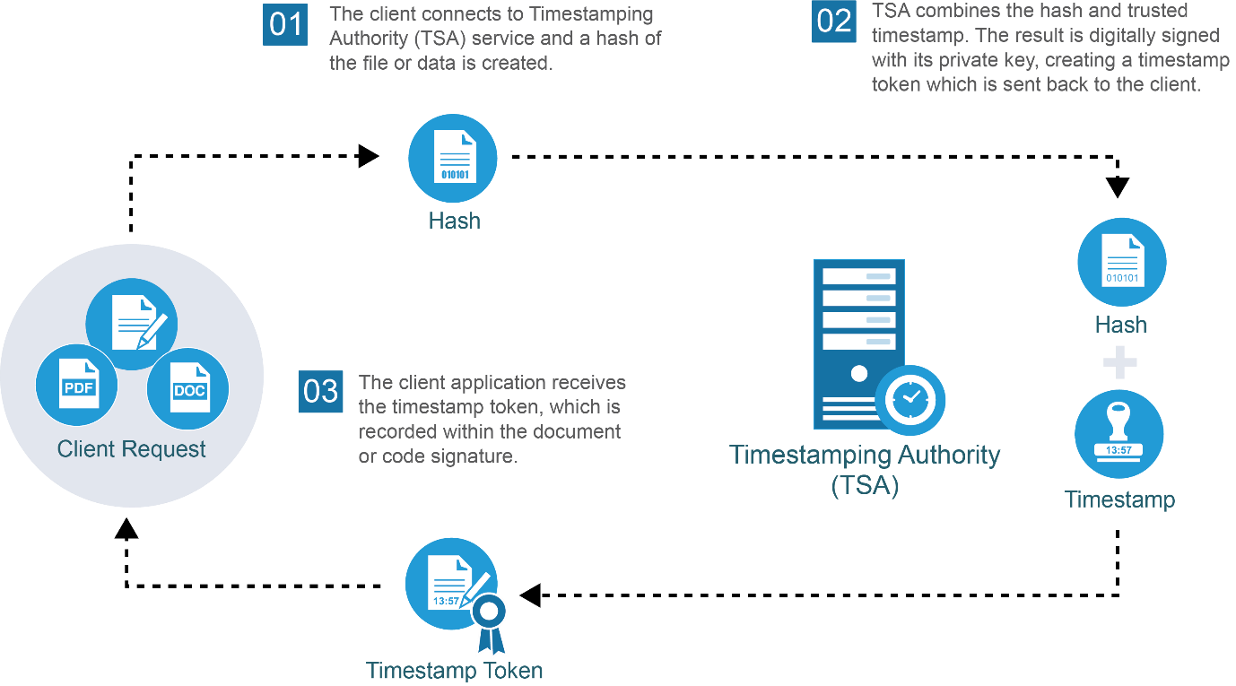

Another important topic when we take a deeper look into how all of this is legal, and works are the ISO 27000 family standards. ISO stands for International Standards Organization which impacts everyone everywhere however physically located in Geneva, Switzerland. ISO standards allow things to work the way they are supposed to, and the 27000-family set specific guidelines for information technologies security techniques. Examples of these family standards are ISO/IEC 27002:2013 which details security techniques that code for practice for information security controls. Furthermore, these standards are kept up to date by being reviewed every 5 years. This year in the 27000 family they have proposed 10, prepping 20, in committee with 30, in enquiry with 40, have approved 50, has publicize 60, is in the process of reviewing 90.20, and withdrew 95 standards so far. (Staff, 2018)

## ***Solutions***

My initial recommended solution to solve all these problems is to create a hash though public key encryption and then adding an extra layer of security by adding a private key encryption for the signature. As mentioned above the problems occurring are not happening because the signatures are not being valid but then they try to become invalid.

However, just having a hash alone will not prevent any problems. We need to implement and create need to create a system that would void these signatures in an instant when contracts fall though. For the auto industry this mean a way after the contract is processed for the system to go back and check if the signer has authorized the following transaction, and for the dealership to confirm that “yes, this offer is still valid”. It may seem that keeping paper documents are more useful in the auto industry, because it is possible rip up a paper contract to invalidate the signature.

By implementing this digital signature protection of your signature, it is possible to instantly use a digital filing system. This will then cause reduction of paperwork an if simple mistakes are made such as misspelled personal identifiable information, an employee can just go back in fix it. At this point making a mistake is not as big of a deal, with humans working systems there are bound to make mistakes, which is okay, but when fixing the mistakes take more effort employees do not want to spend the time to fix it all. It is common business knowledge that time is money. So basically, to save time means to make money. Therefore, often we even have people making these types of careless mistakes and try to have them go unseen.

## ***Conclusion***

In conclusion, the way the auto industry is running today is an outdated way that not only is inefficient but also non-productive and promotes ways that customers can get frauded and scammed with. However, as evident in the previous analysis the problem in the auto industries signature problems are not from the lack of protection of the signature but the fact that a signature cannot be automatically invalidated.

In contrast to other industries that use DocuSign systems such as real estate, the biggest difference between the auto and others is the time. To land real estate in your name, the process can take anywhere between 60 to 90 days with many backs and forth with banks, agents, buyers and sellers. In the auto industry we try to drive home with the car that we have purchased as soon as possible.

Additionally, the initial cost for this idea to the business in the starting phases will be very low because the most important thing that needs to be done first is to research more and get a team together of knowledgeable professionals from the auto industry, DocuSign and ISO 27000 to go through an experimental process to come up with what we need to accomplish. This is needed because business is interconnected and a problem like this does not only have one solution that can be just bought into existence. This solution needs to be developed and tested before anything can be done to change in the ways that we conduct business.

Finally, as I finish writing my paper to you Mister/Misses CIO I urge you to realize that this minute problem needs to be fixed so that the auto industry can be more efficient in the ways they are conducting business. The world is moving towards a more high-tech environment, we do not want the auto industry to be the only industry soon to be the only one that still uses all these resources to conduct business and not have a settled way of getting electronic signatures.

Eventually, as we- the auto industry keeps this up, we will lose these customers. I say this because other industries in public transportation are now on the rise and if someone does not find the need to buy a car they are more than likely to be using public transport. Fortunately for the customers, to get a Marta pass it does not require any type of signature. And to the places where Marta does not reach, we have Ubers, Lyfts and now a market of electronic scooters such as Byrds and Lime.

So, for the ease of access for all people in the industry and the promise of rising profits, it is vital that this report and its recommendations and information strikes a chord with you and helps to begin a start of change for the better of the auto industry and therefore finally allowing a progression and means of securing of the auto industry.

Thank you,

Shaheda Choudhury

Atlanta, GA

[Schoudhury5@student.gsu.edu](mailto:Schoudhury5@student.gsu.edu)

770-560-2644

# **Part III. Sources**

A.(2017, April 27). DocuSign and electronic signature law. Retrieved October 6, 2018, from <https://www.docusign.com/how-it-works/legality> (2017)

Laporte, J. (n.d.). Topic: Car Drivers. Retrieved October 6, 2018, from <https://www.statista.com/topics/1197/car-drivers/> (Larporte)

Staff, I. (2018, July 15). ISO - International Organization for Standardization. Retrieved October 6, 2018, from <https://www.iso.org/standard/54534.html> (Staff, 2018)

Klingel, L. (2018, May 02). DocuSign: Your electronic signature is worth billions. Retrieved October 6, 2018, from <https://www.foxbusiness.com/markets/docusign-your-electronic-signature-is-worth-billions> (Kingel, 2018)

What is Timestamping? (n.d.). Retrieved October 6, 2018, from <https://www.globalsign.com/en/blog/what-is-timestamping-how-does-it-work/> ()